**Practical File**

***Lab Name………COA LAB………………….………………………….………. Lab Code……KCS-352***

.



**Name….……SAMARPIT DUA……………………………………………..**

**Adm.No…2019B111068… Univ. Roll No….1900321290050…**

**Course B.TECH……Branch………………CEIT…….…………..**

**Sem…………3………… Section………A.…..**



1. **PROBLEM STATEMENT:** In this we have to convert binary number into gray code

and vice versa.

1. **OBJECTIVE :** Implementing Binary -to -Gray, Gray -to -Binary code conversions. Using COA Simulator in the following ways

* Binary to Gray code using simple logic gates
* Gray to Binary using simple logic gates
* Binary to Gray code using NAND gates
* Gray to Binary code using NAND gates
* Binary to Gray code using NOR gates
* Gray to Binary code using NOR gates

1. **DEFINITION OF GRAY CODE AND BINARY CODE:**

**Gray code** – also known as Cyclic Code, Reflected Binary Code (RBC), Reflected Binary (RB) or Grey code – is defined as an ordering of the binary number system such that each incremental value can only differ by one bit. In gray code, while traversing from one step to another step only one bit in the code group changes. That

is to say that two adjacent code numbers differ from each other by only one bit.Gray code is the most popular of the unit distance codes, but it is not suitable for arithmetic operations. Gray code has some applications in analog to digital converters, as well as being used for error correction in digital communication. Gray code can bedifficult to understand initially, but becomes much easier to understand when we look at tables

**Binary to Gray Code Converter**The logical circuit which converts the binary code to equivalent gray code is known as **binary to gray code converter**. An n-bit gray code can be obtained by reflecting

an n-1 bit code about an axis after 2n-1 rows and putting the MSB (Most Significant Bit) of 0 above the axis and the MSB of 1 below the axis.

1. **TABLE:**

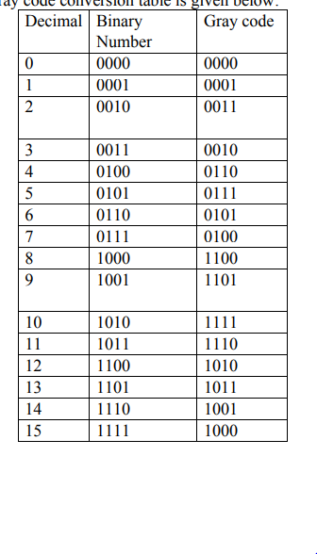

1. **IMPLEMENTATION:**

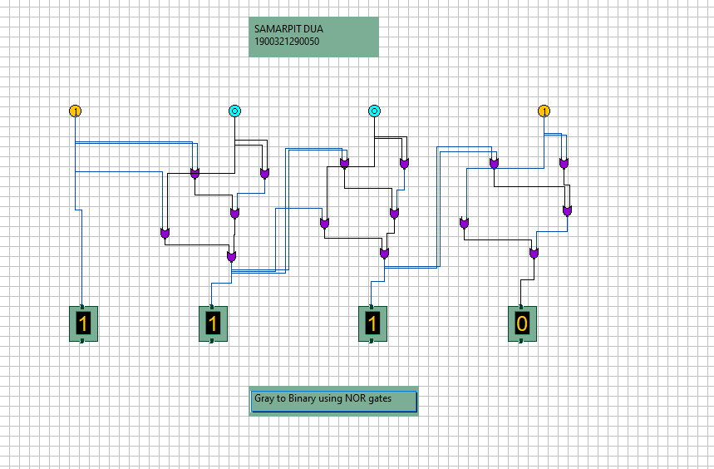

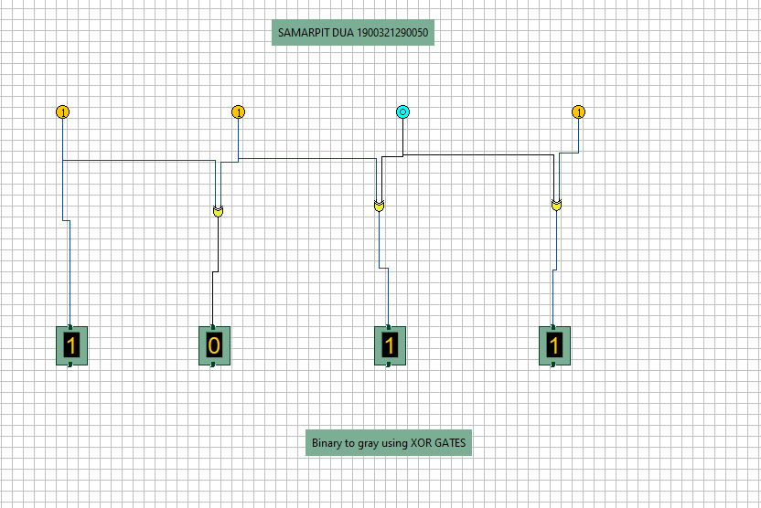

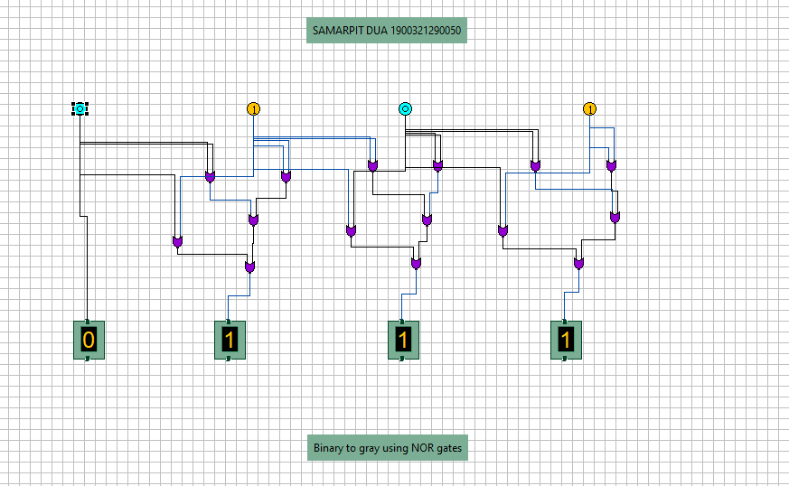

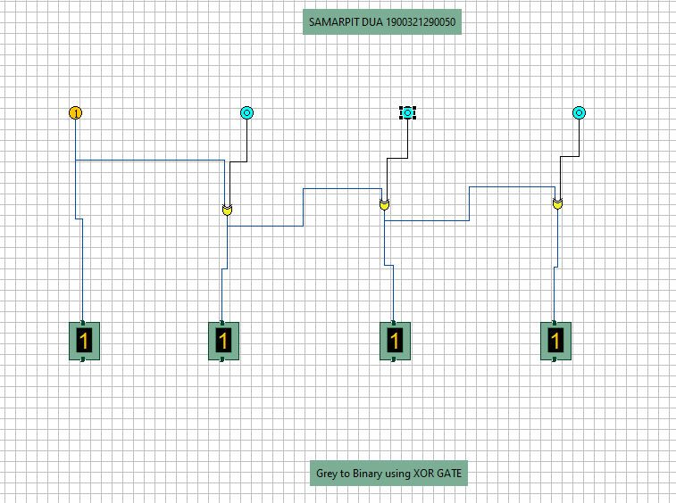

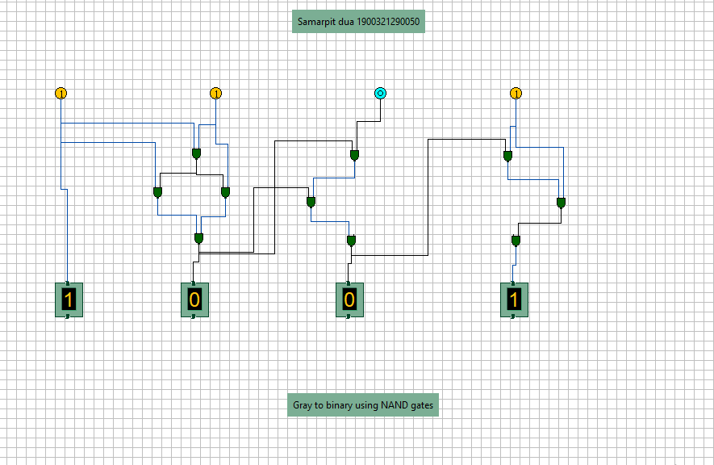

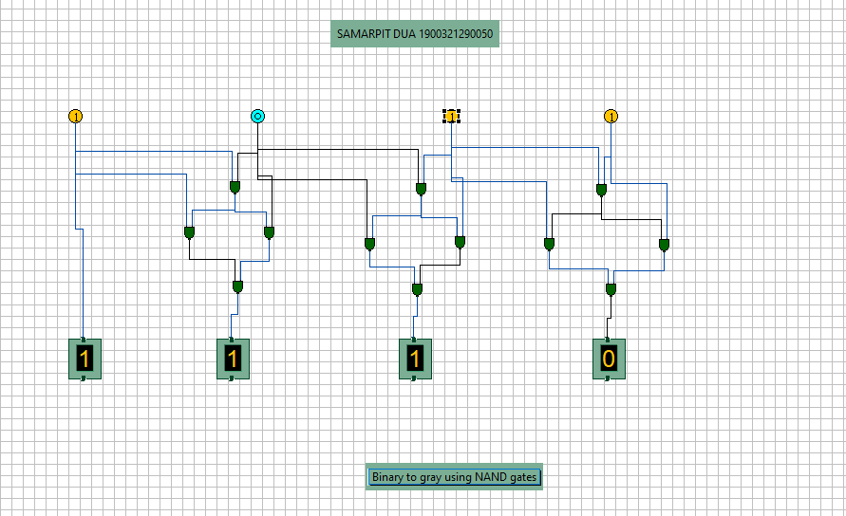

**6.RESULT:**Thus with the help of the logic gates(XOR,NAND,NOR) as shown, we can easily convert GRAY code to BINARY code and visa-versa.